CMPE172

HW6

Tableau

Team GreenFace

Minh Ngo, Viet Nguyen and Hoa Nguyen

1. **Drag and drop dimensions to create graph of data**

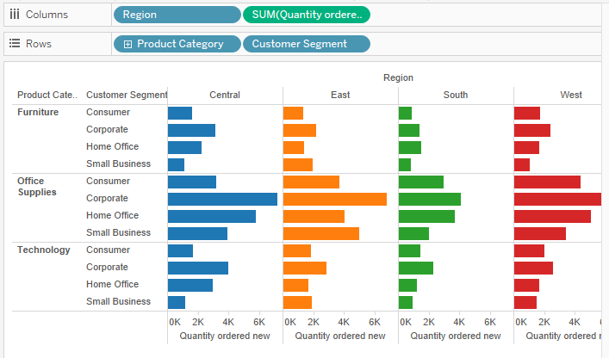

**Figure 1 Graph of Order Sum and Product Category**

1. **Adding SUM(sales) into Tooltip to display additional information about YOY growth**

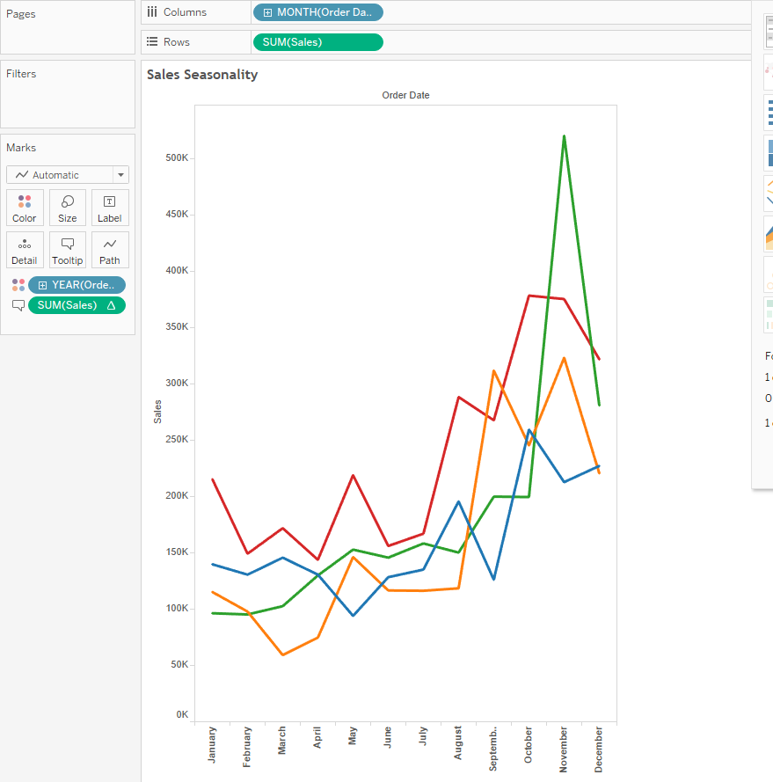

**Figure 2 Graph of Order Sum with YoY Growth**

1. **To check the performance of product categories and leave comment (annotation) on the data visualization**

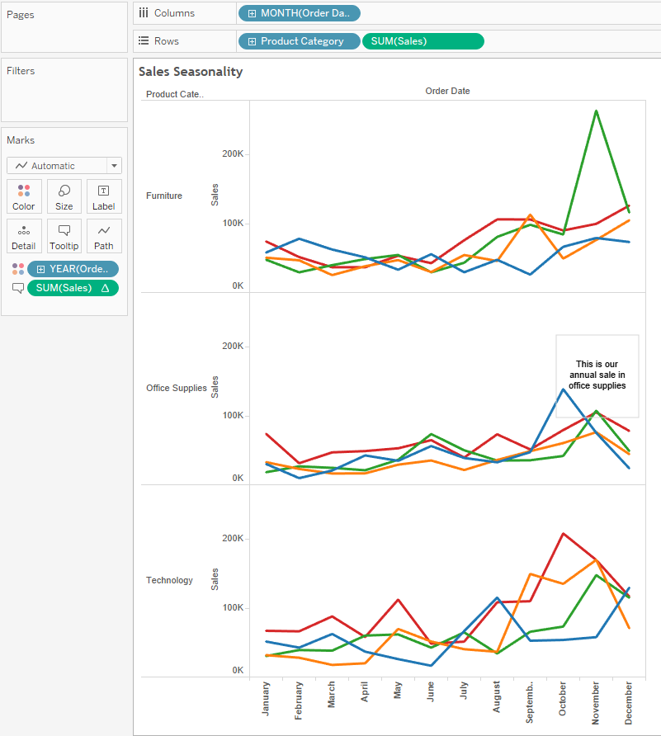

**Figure 3 Graph of Order Sum per Category with annotation**

1. 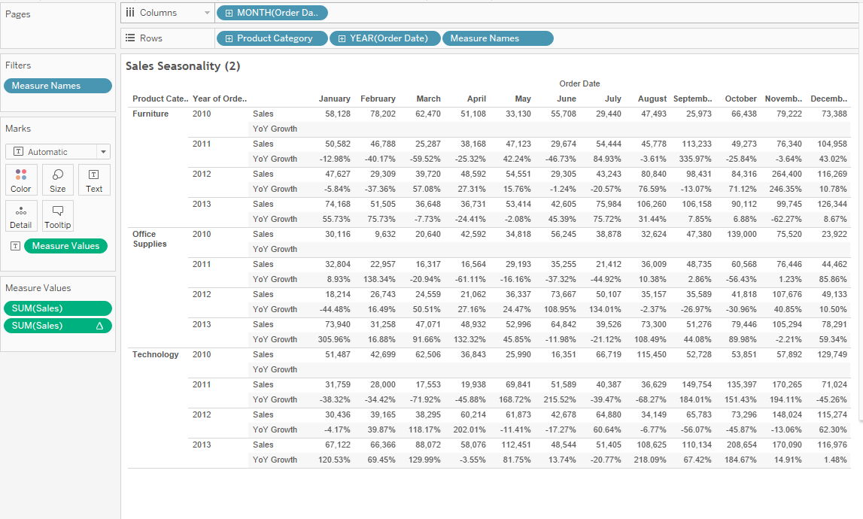E**xport data to Excel file (raw data export) or duplicate as crosstab inside Tableau desktop**

**Figure 4 Raw Data in new Tableau Crosstab**

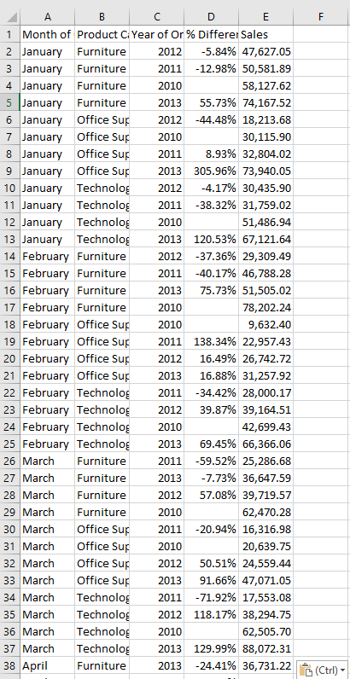

**Figure 5 The same data as Figure 4 in Microsoft Excel Worksheet**

1. **Check for profit performance in annual sale (in the cross tab) by using the highlighted table**

Coloring (Under Marks menu, select Square, enable Show Mark Labels under Label option) and marked up by square and label (turn on mark label)

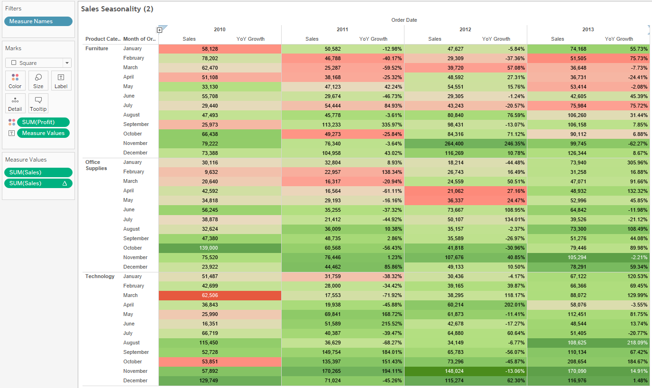

**Figure 6 Product Performance and Annual Sale Graph**

1. **Check for sale performance across different regions by 3 categories of furniture, office supplies and technologies**

We focus on sale performance in term of city and state. We do so by coloring profit and categories.

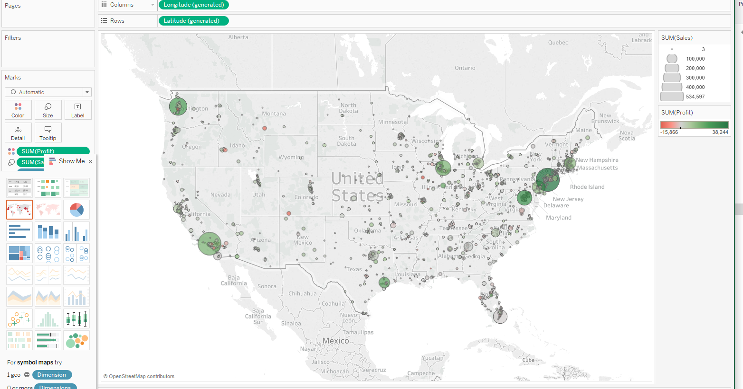

**Figure 7 Sale Performance in cities and states**

Highlight poor profit categories (Filter by product category)

**Figure 8 Filtering The Sale Performance Map**

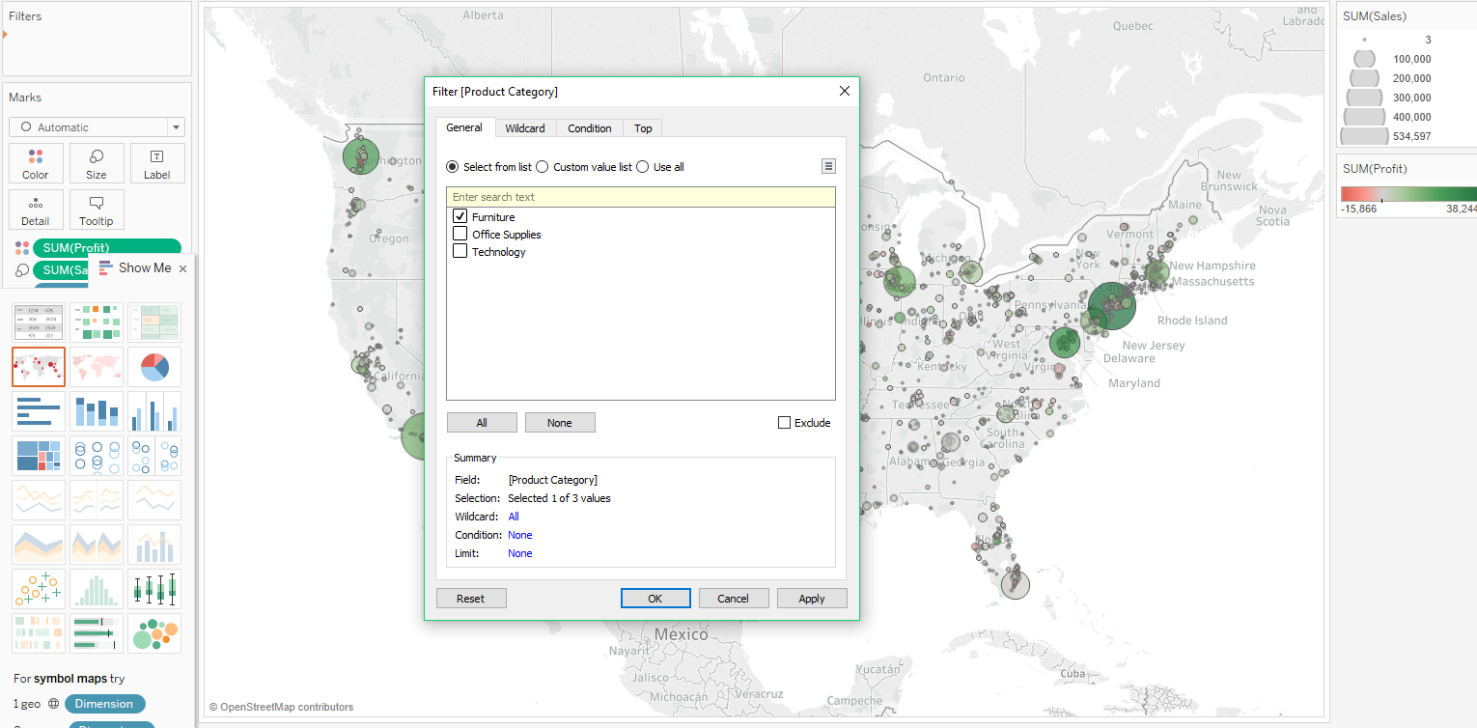

This is the end result of previous step.

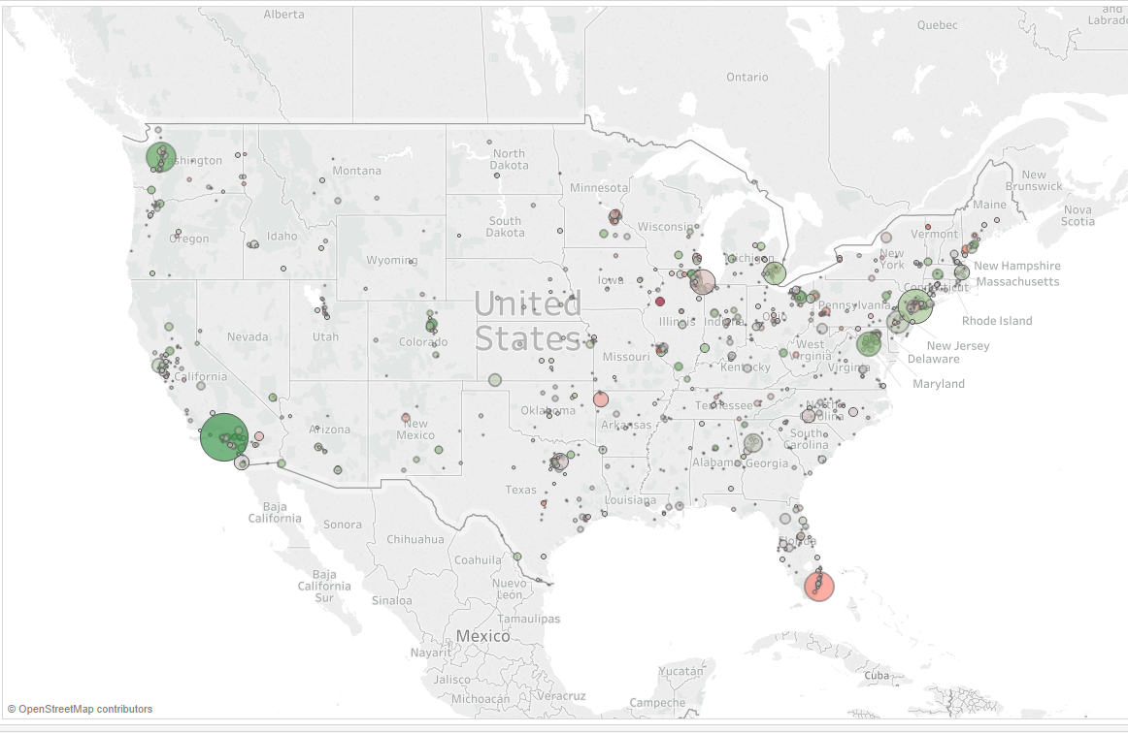

**Figure 9 Sale Performance Map after filtering**

1. **Check for specific information for the poor sale performance of furniture (product category)**

Choose product category, product sub category and sale to create bar chart

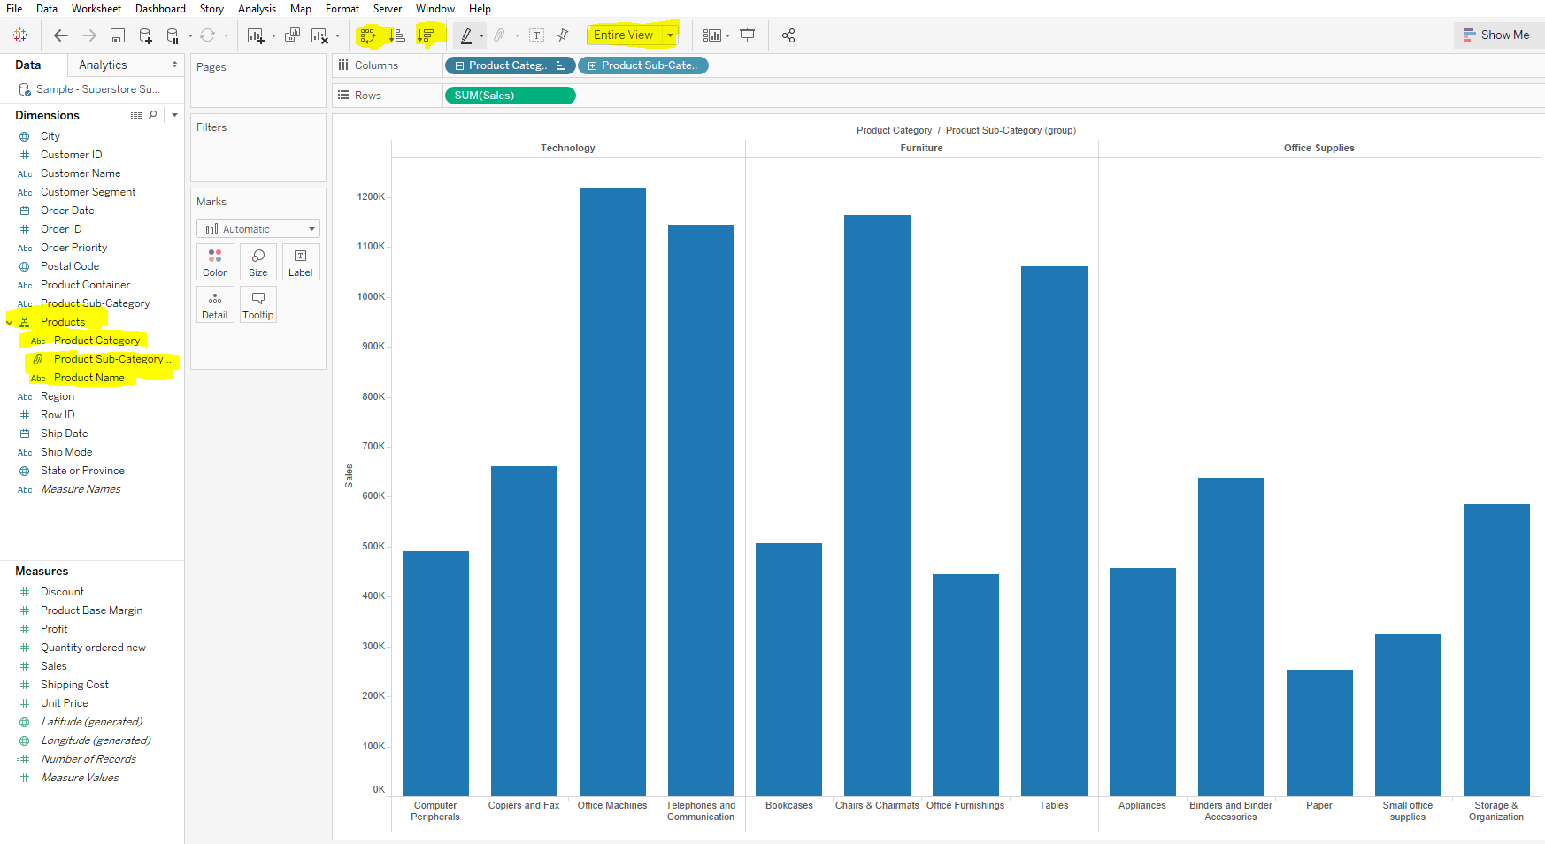

**Figure 10 Product Sale Bar Chart**

Create product hierarchy, switch axis for easier view, click entire view to display all information in the same view

Sort the product category descending by sale

Check the performance of each region in term of profit (drag and drop profit to color tab and drag region the sale axis)

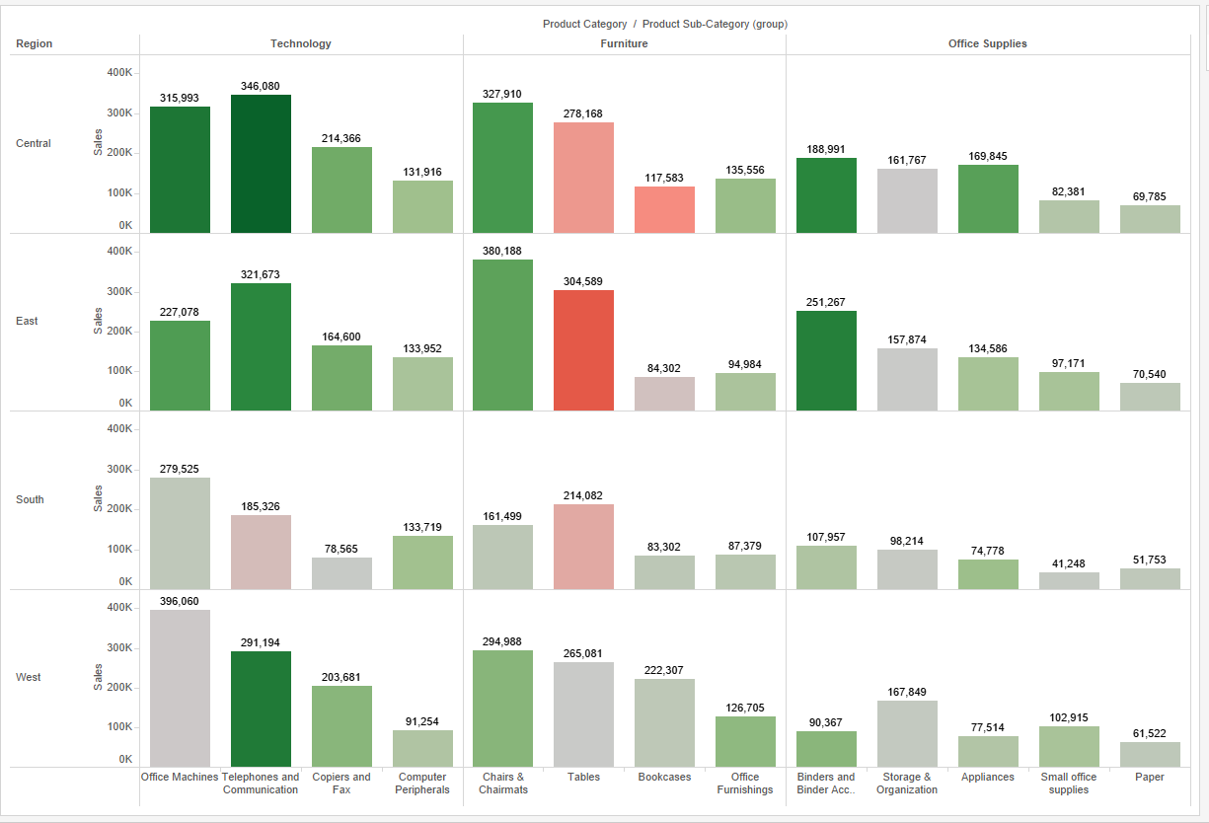

**Figure 11 Sale Performance for each region**

Group poor sale-profit products into 1 group (name them as small-office supplies)

Simplify the view to highlight important information 7.2

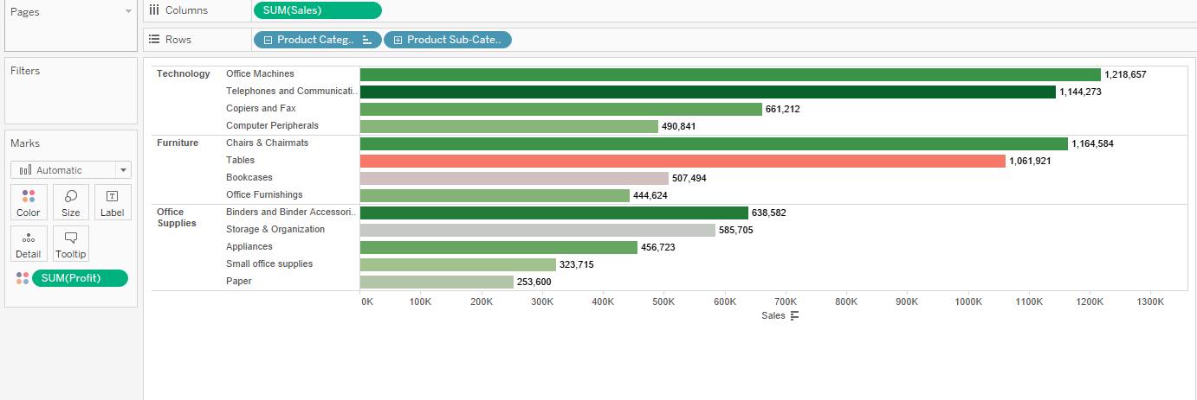

**Figure 12 Sale Performance Bar Chart under simplified view**

1. **Create a new tab for Customer Breakdown to analyze the shipping cost depending on region for each customer**

Place profit into the row cell, shipping cost into the column cell, region into the cell, customer on the detail tab

Plot the data and aggregate them on the plot. 8

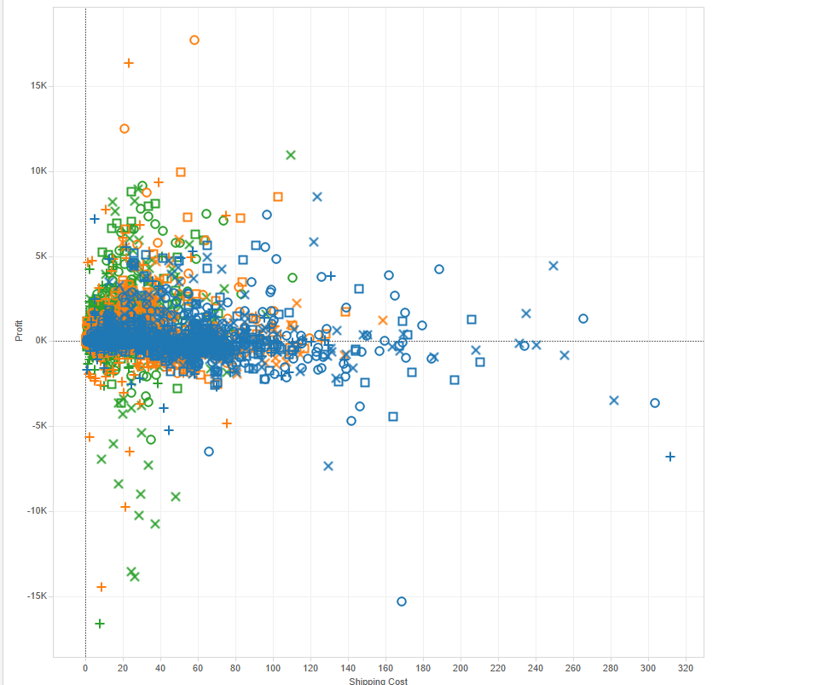

**Figure 13 Shipping Cost Scatter Graph**

Disaggregate the data, and we have the below:

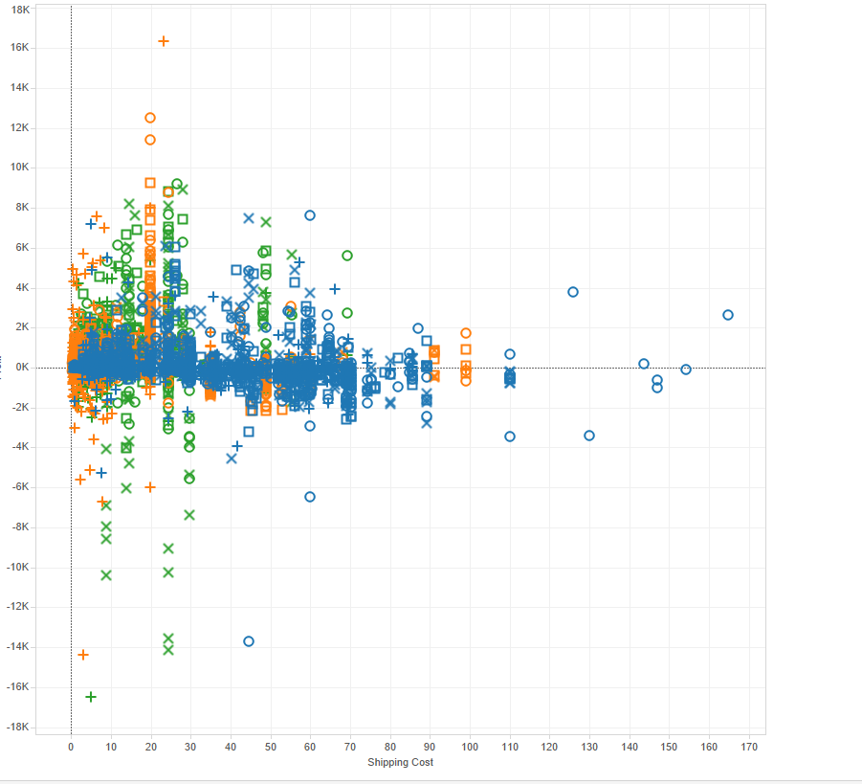

**Figure 14 Shipping Cost Graph after disaggregation of data**

Adding more information (more labels) onto the plot of Figure 14

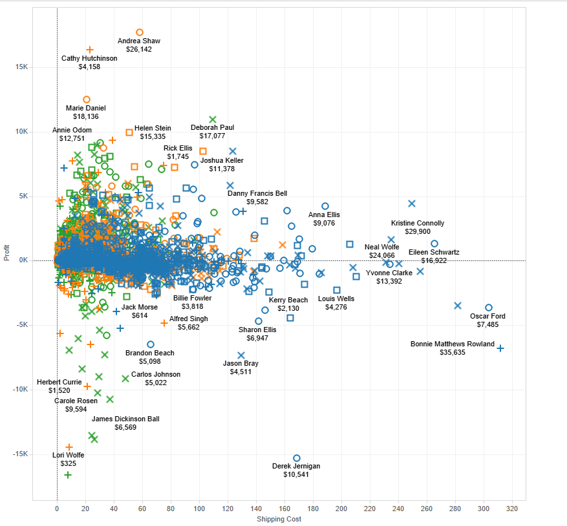

**Figure 15 Shipping Cost Graph with labels**

Show trend line

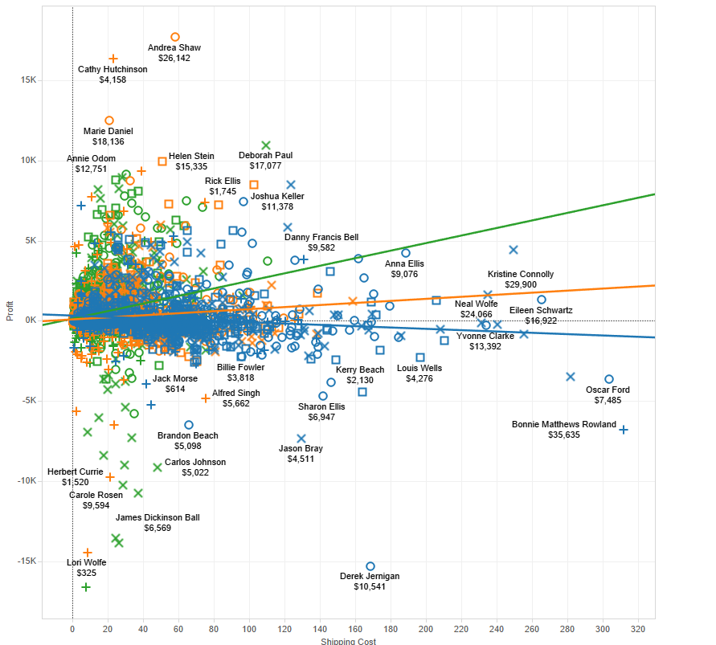

**Figure 16 Shipping Cost Graph with labels and trend lines for each product category**

Copy the underline (raw) data and export to Microsoft Excel for detail information

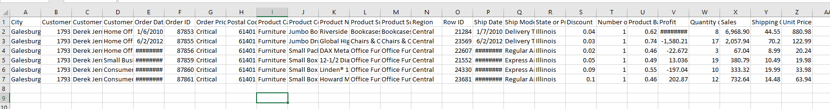

**Figure 17 Export data to Microsoft Excel Worksheet**

Create a dashboard

Combine sale by category tab and sale by regional tab into 1 dashboard 8.6

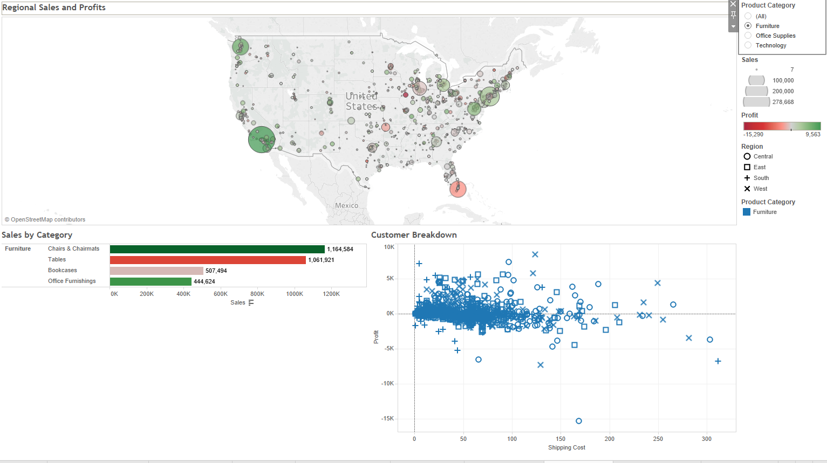

**Figure 18 Dashboard of Sale by Region and Sale by Category**

Create dashboard for office supplies.

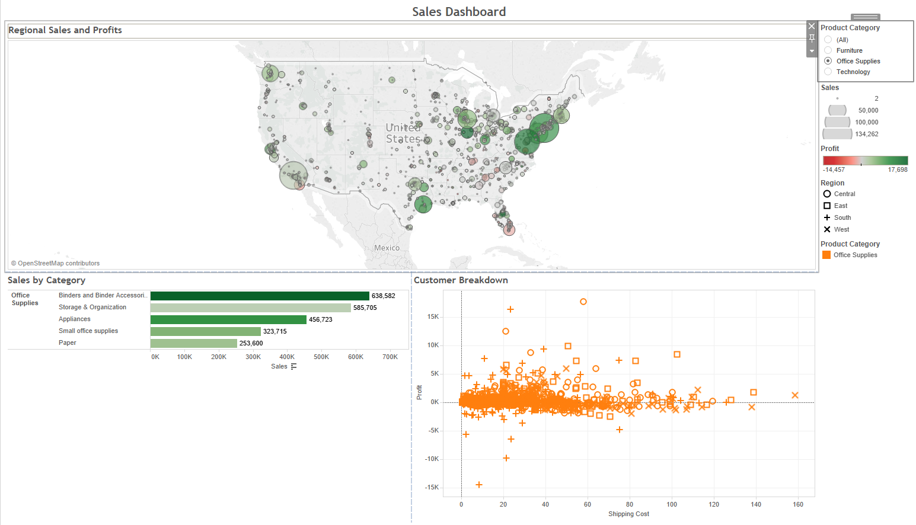

**Figure 19 Dashboard for Office Supplies**

Create dashboard for technology

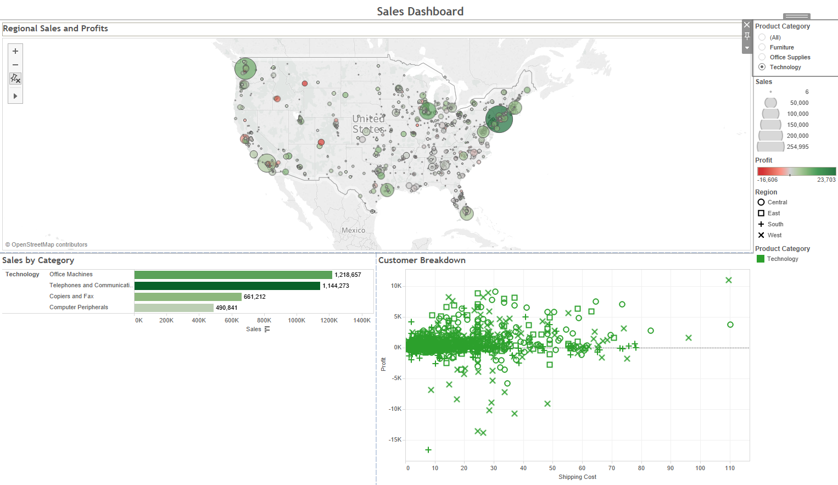

**Figure 20 Dashboard for Technologies**

1. **Create a story**

Snapshot a visualization of the data

Add annotation to notable parts of the visualization

Name the story as “Profitability-the story)

Snapshot #1 “Overall our profit looks strong” 9

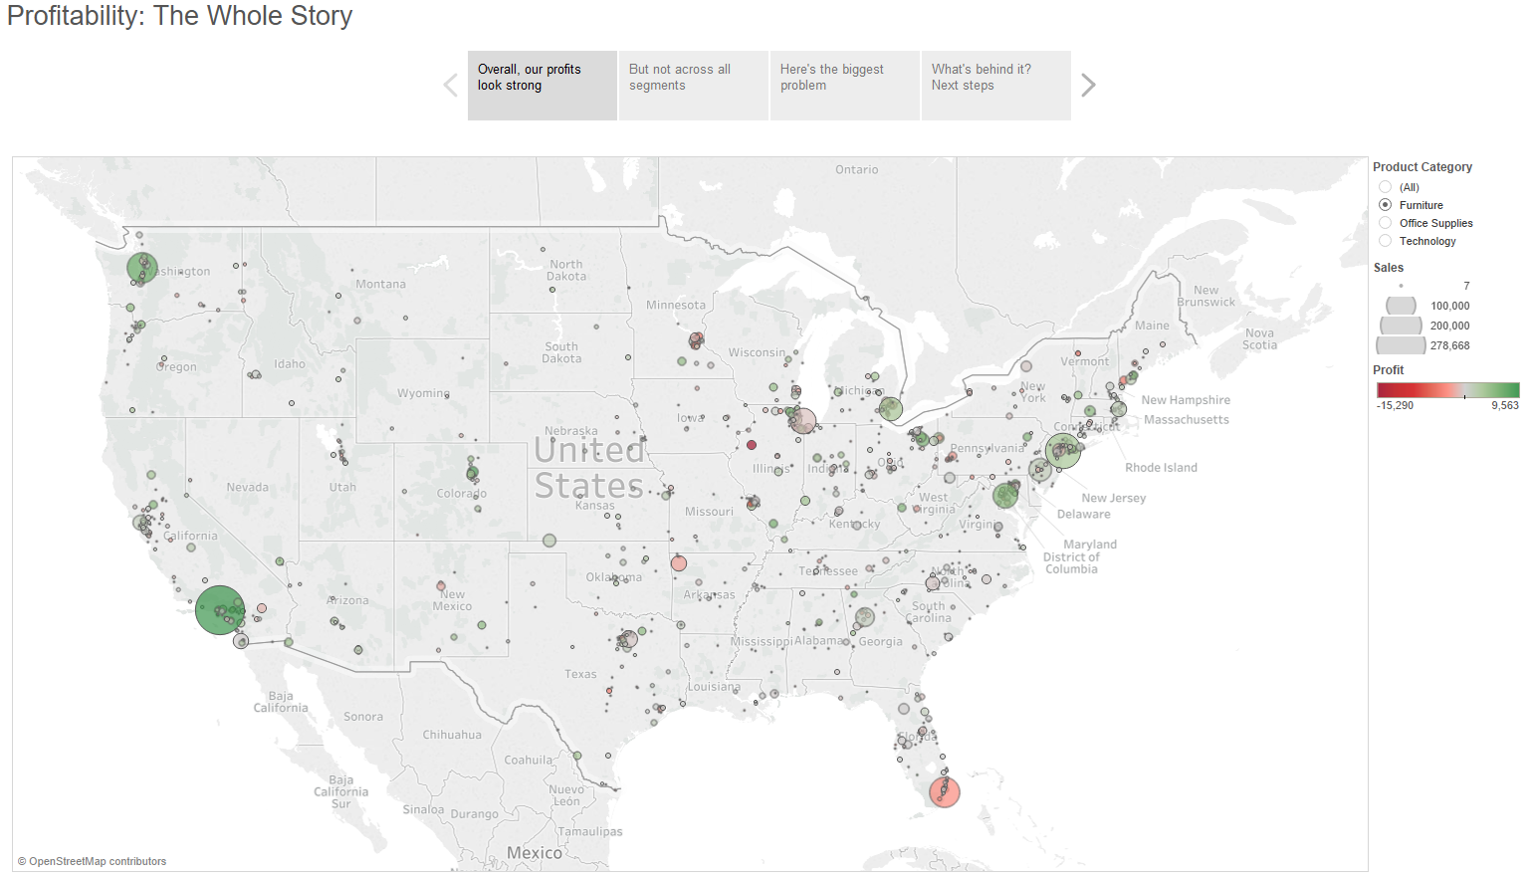

**Figure 21 Snapshot #1**

Snapshot #2 “But not across all segments” 9.1

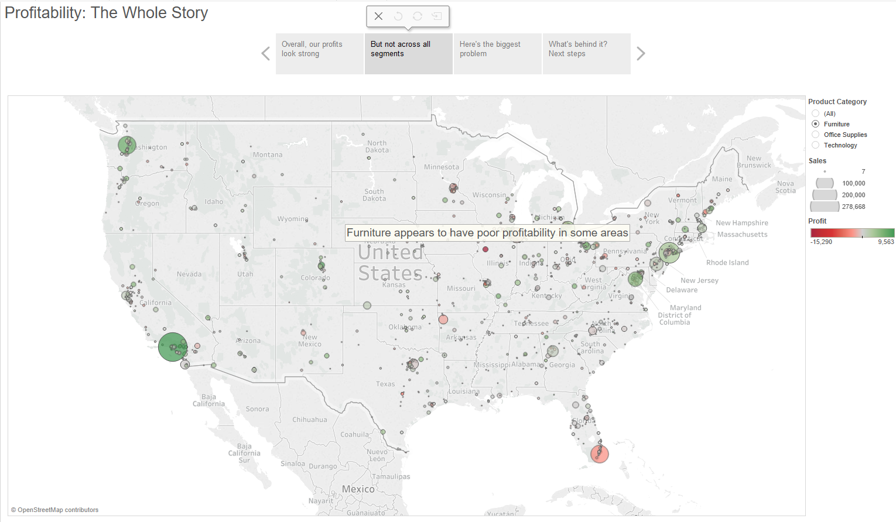

**Figure 22 Snapshot #2**

Snapshot #3 “Here’s the biggest problem” 9.2

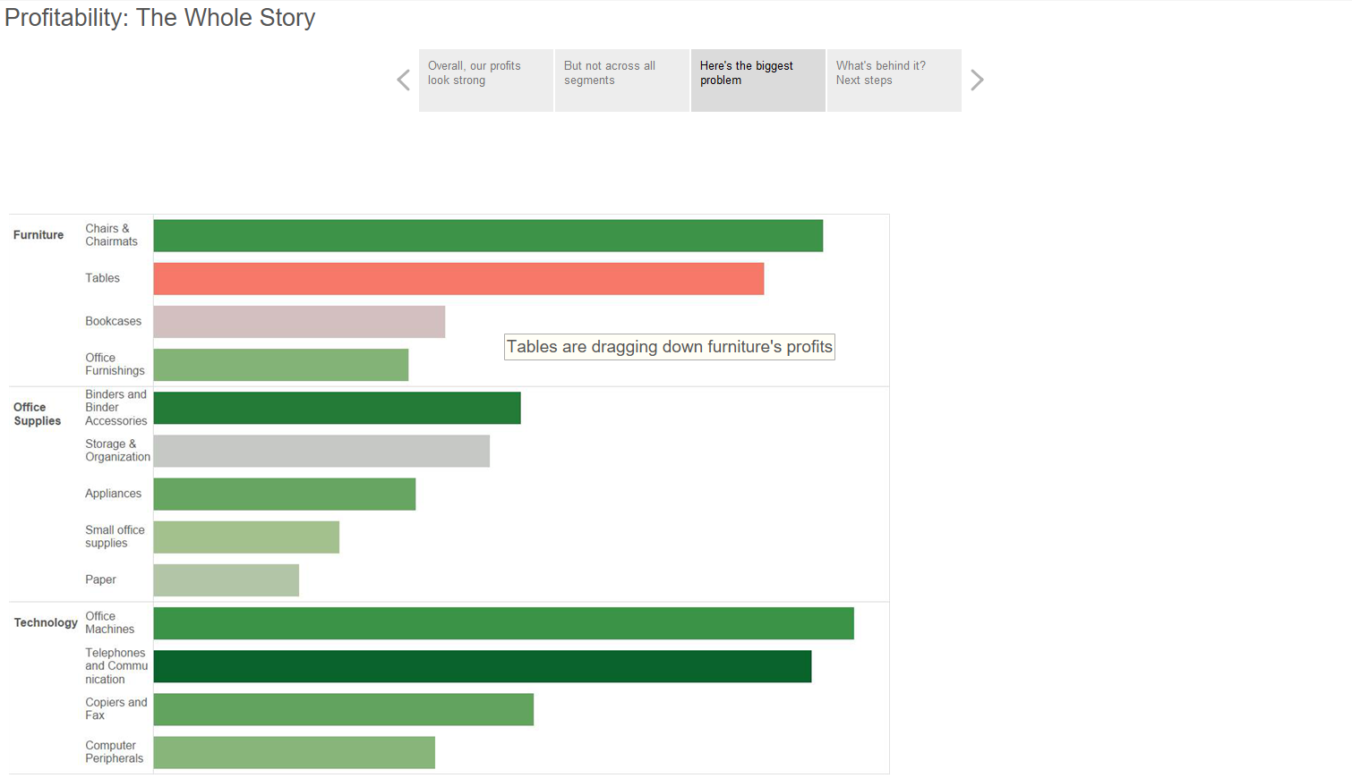

**Figure 23 Snapshot #3**

Snapshot #4 “What’s behind it? Next Step” 9.3

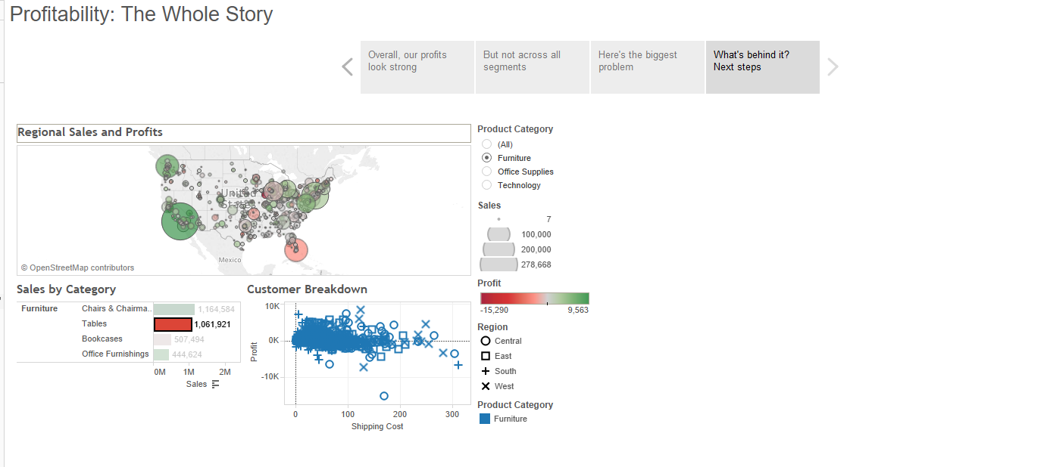

**Figure 24 Snapshot #4**